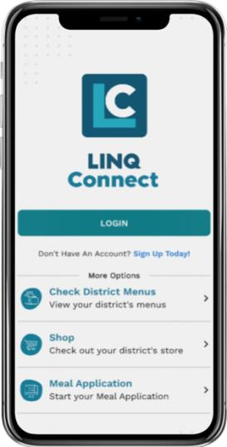
NEED ADDITIONAL
SUPPORT?

support@linqconnect.com

www.linqconnect.com

DOWNLOAD THE APP:

Apple
Store:

Google
Play
:

The LINQ Connect app is a mobile app available for families to add money to meal accounts, add district menus, and set spending limits.
The LINQ Connect app allows families to:
- Set up reminders and be alerted when your student’s account is running low.
- Check your student’s purchase history to see the purchases they make.
- Apply for free or reduced meals directly from your device.
- Set up Auto Pay and eliminate the worry and remove the worry of your student losing lunch money.

App

FAQs

How do I get started?

1. Download
Download the LINQ Connect app from the App Store or Google Play.
2. Register
Create an account by selecting Register.

3. Confirm Email
Confirm your account by clicking the verification link sent to your email.

4. Log In
Log into the LINQ Connect app using your email and password.
© 2023. EMS LINQ, Inc. All rights reserved. LINQCONNECT.COM

How do I add my child’s account?
You will need to add your children to your LINQ Connect account. Click on + then Type and complete the information to link your child. You will need to complete this process for each child you wish to add.
How do I add money to my child’s account?
Once you have added your child to your LINQ Connect account, you can add money by clicking the Add Money to Account button on the dashboard or by clicking the Meal Account button on the student card. You can choose either One-Time Account Payment or New Recurring Payment with Auto Pay.
If you select Add Money to Account, funds will be immediately available on your child’s account upon completion of the transaction.
If you select New Recurring Payment with Auto Pay, you will be setting up an automatic payment. Please note that these funds will not be immediately available on your child’s account.
Can I set spending limits on my child’s account?
You can set specific spending limits on your child’s account only if your school district has added the spending limits feature. To determine if you have access, navigate to the Spending Limits card on the Meal Accounts page, and locate your student’s name. Click on the pencil to the right, where you can set a spending limit.
How do I set up recurring payments?
Click + and Add Money to Account. Click New Recurring Payment with Auto Pay. Enter the Payment Amount for each child, and set the Frequency, Day, Starting Date, Billing Address, Payment Method, and then click Save.
Can I receive a notification when my child’s account balance is low?
Yes. The system is defaulted to send an email reminder when the balance falls below $5.00. You can change the Payment Reminder by editing the dollar amount on the Payment Reminder card on the Meal Accounts page.
Can I apply for free/reduced meals on the app?
Yes. Click + and select Apply for Meal Today. Find your district, and then enter your information in the form. You can add an Income Form from the app by selecting + New Income Form.
LINQCONNECT.COM

LINQ
CONNECT
.COM

Is there a fee or service charge for making payments online?

Yes, you
can find the processing fee during checkout.

What happens to the money in my child’s account at the end of the
school year?

Y
our account balance moves with your child from grade to grade and school to school
(
within the district
).

How can I see activity on

my child’s account?

Once you “buy” a fee, you’ll be able to see the itemized purchase by clicking on
Transaction

>

History
. You will receive an email with the transaction history.

Can I see my child’s school menus on the app?

Yes, if the school is using TITAN Menu Planning. Go to
Menus

and enter your district’s
name to view their meal menus.

How can I update my email address and password
?

In the upper right
-
hand corner, click on your name. To change your email address, select
the
Update Email

button. To update your password, click on
Update Password
.

How do I add a payment method
?

Go to
Profile

>

Payment Methods
, then select
Add New Payment

Method
.

Can I access my account through a browser
?

Yes, you can access your account by visiting
https://linqconnect.co
m

on any browser
except Internet Explorer, which is no longer su
pported.

